Margo Apostolos, PhD 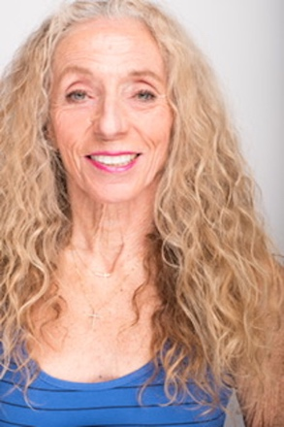
Professor
margo@us.c.edu
213 760-3735 (mobile)
USC Glorya Kaufman School of Dance
Co-Founder and Co-Director,
Cedars-Sinai/USC Glorya Kaufman Dance Medicine Center .

Dr. Apostolos has authored and presented numerous articles on her research and design in robot choreography. In addition to her PhD and post-doctoral studies at Stanford University, she earned an MA from Northwestern University. She has served as visiting professor in the Department of Psychology at Princeton University and has taught in Chicago, San Francisco, Stanford University, Southern Illinois University and California Polytechnic State University-San Luis Obispo. Dr. Apostolos previously worked for NASA at the Jet Propulsion Laboratory/Cal Tech as a research scientist in the area of space telerobotics and is the recipient of the prestigious NASA/ASEE Faculty Fellowship.
At USC she served as Director of Dance in the School of Dramatic Arts for 27 years and currents serves as a Full Profess in the USC Kaufman School of Dance and Past President of the USC Faculty and Academic Senate. She continues work in Robot Choreography/ Human and Machine Interactions , Health and Fitness, and Dance Medicine. Apostolos has trained numerous professional and Olympic athletes from a variety of sport swith her dance/sport training techniques.
As an author, Apostolos’ books include:
- Dance For Sports: A Practical Guide, published by Oxford University Press was released in 2019 and remains popular an relevant today.
- Dance As A Catalyst: An Interdisciplinary Journey published by Kendall-Hunt Publishers was released in Fall 2023.
- Robot Choreography and her pioneering work is the topic of her latest upcoming book.

